SPS9 Invited Speaker Information
Associate Professor Debra Waters
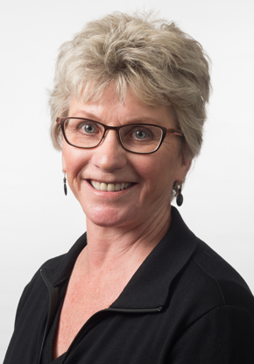
Associate Professor Debra Waters is the Director of Gerontology Research at the University of Otago, the Director of Ageing Well National Science Challenge, and Vice President of the New Zealand Association of Gerontology. She is an exercise physiologist by training and has been engaged in sarcopenia research for over 20 years. This research has led to collaborations in the US, Europe, Australia, and Asia and work with international task forces focused on the prevention and treatment of this geriatric syndrome.
Title: Identification and Treatment of Sarcopenic and Frail Older Patients
Abstract: Sarcopenia (loss of skeletal muscle mass and function) and frailty is prevalent in older adults, as is the growing prevalence of sarcopenic-obesity with frailty. Although criteria/cut-scores for sarcopenia are still being debated, there are clinical screening tools and algorithms that can applied to identify sarcopenia, frailty, and obesity in older adults.
This talk will present the current thinking around sarcopenia, frailty and obesity identification in older adults and also present data showing that combined aerobic & resistance exercise may provide greater improvement in physical function and reversing frailty than either intervention alone.

Dr Ben Darlow
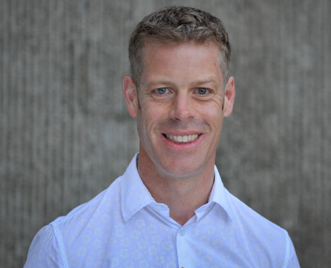
Ben is a Musculoskeletal Physiotherapy Specialist practising in Wellington and a Senior Lecturer in the Department of Primary Health Care and General Practice at the University of Otago, Wellington. He is also a member of the Physiotherapy New Zealand Professional Development Committee. Ben’s research focuses on understanding beliefs about common musculoskeletal conditions and designing, testing and implementing interventions to improve knowledge, health care delivery, and outcomes.
Title: Thinking about OA: opportunities to enhance care and quality of life
Abstract: Beliefs about OA and how it should be managed shape the information and care that is offered to people with OA and the strategies in which people with OA engage. Ultimately, the way in which clinicians and consumers think about OA influences activity levels, social and leisure participation, and emotional wellbeing. This presentation will describe: i) qualitative research with individual consumers that has highlighted the consequences of consumers’ biomechanical understanding of OA and the influence of clinicians on consumer beliefs, and ii) international survey research that has highlighted opportunities to enhance primary health care workforce knowledge and capacity. Optimising the way in which clinicians and consumers think about OA represents a significant opportunity to enhance care and quality of life.

Dr Hilda Mulligan
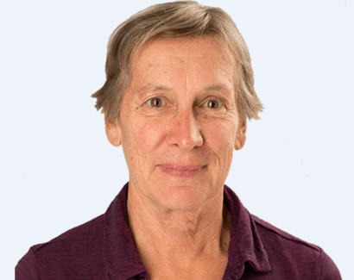
Dr Hilda Mulligan was born and brought up in South Africa, but has lived in Aotearoa/New Zealand for 30 years. She has had many enjoyable years working as a clinical physiotherapist in hospital, private practice and community settings both in South Africa and then in New Zealand. Hilda undertook masters and then PhD studies in NZ when these programmes became available to physiotherapists and now holds a Senior Lectureship at the School of Physiotherapy, Otago University. Her clinical teaching develops students’ independence of thought and action, and her research fosters health and well-being of individuals through enabling people having choice, control and support to be physically active and connect meaningfully with others within society. Most recently Hilda has been part of the WellConnectedNZ project, a collaboration between researchers from Otago University, Canterbury District Health Board, and Canterbury University GeoHealth, and funded by the Health Research Council of New Zealand. This research project has culminated in the drawing together of years of Hilda’s clinical and research expertise for the betterment of health service delivery. For leisure, Hilda enjoys cycling, walking, swimming, gardening and dancing Argentine tango.
You can listen to a podcast of Hilda’s research bio here
https://drive.google.com/open?id=16Sx9vWDiNw9jpSjpTYFEmBAWn2v70Xyf
Title: My life in physiotherapy as a clinician and researcher
Abstract: As Hilda approaches retirement from her professional vocation, this presentation will reflect on what she has learnt about physiotherapy and its interactions and relationships with patients over a long and satisfying career. She will share stories to illuminate why and how she has learned to listen more to patients, recognise people as the experts of their own bodies, consider patients in their individual contexts, and consider patients’ preferences and well as their health needs. She will reflect how an important part of our work as physiotherapists is to advocate for health services that provide and allow for meaningful change in patients’ lives. Lastly, she will argue and illustrate that people thrive when they have opportunity to build meaningful connections with others, including with us as physiotherapists.

Dr Richard Ellis
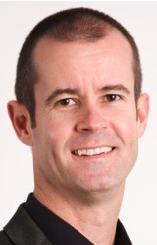
Richard is a Senior Lecturer in the Department of Physiotherapy at Auckland University of Technology (AUT). He teaches on both the undergraduate and postgraduate programmes in the fields of musculoskeletal physiotherapy, manual and manipulative therapy, ultrasound imaging and research. Richard is also an Associate Head of Research for the School of Clinical Sciences and a Co-Director for the Health and Rehabilitation Research Institute at AUT.
Richard’s primary research interest is the exploration of and understanding the biomechanics of the peripheral nervous system, in particular how this may influence clinical assessment and management of peripheral nerve disorders. Much of this research has utilised ultrasound imaging to gain a real-time, in-vivo perspective of the different biomechanical features of the nervous system.
Richard is also interested in the role of ultrasound imaging for clinical practice and research for physiotherapists and other allied health professions. This has led to his development of UG and PG courses in ultrasound imaging. Richard is a musculoskeletal physiotherapist, so he is also interested in research which looks at the role of manual therapy and physiotherapy assessment and management.
External to AUT, Richard is a Senior Tutor and Executive Committee member with the New Zealand Manipulative Physiotherapists Association (NZMPA). He is also an Associate Editor for the New Zealand Journal of Physiotherapy.
Title: Towards a better understanding of peripheral nervous system disorders
Abstract: Scientists and medical professionals have been interested in the assessment and treatment of disorders of the peripheral nervous system (PNS) since the 1800’s. We have come a very long way since the first report of the Lasegue’s sign (what we now know as the straight-leg raise test) that was first published in 1864. PNS research in cadaver and animal models in the 1950-60’s were the foundations of the emergence of neurodynamics in the mid-late 1990’s. The emergence of ultrasound imaging (USI) as a method of real-time, in-vivo analysis of the PNS allowed the first robust examination of many credible clinical theories regarding the influence of nerve movement, stretch and strain upon neurophysiology. Since this time, the assessment and treatment of PNS disorders has transformed. As technologies continue to evolve and more clinical questions are asked, the potential for practice to change and adapt is ever more critical. This presentation will explore how our clinical management of PND disorders started, has adapted, and where the future may take clinicians.

