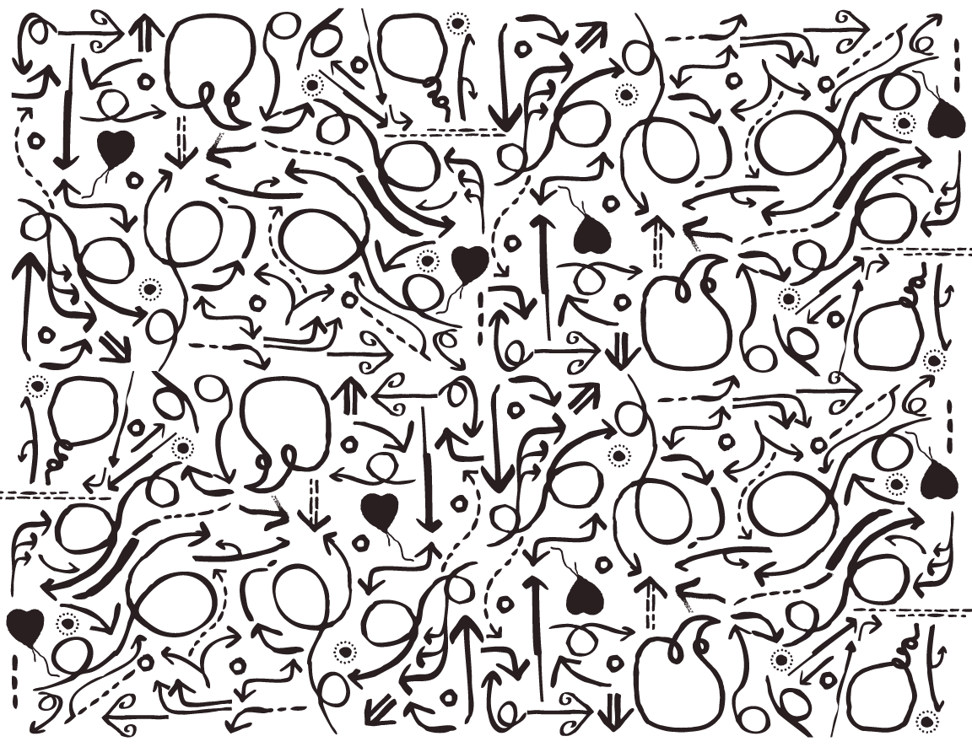­­

Physiotherapy New Zealand  
Future State Proposal

Operating Model – For Review

VERSION: FINAL



**Submitted:** June 2018  
**Version:** FINAL



**Physiotherapy New Zealand**

PO Box 27 836, Wellington 6141

www.physiotherapy.org.nz

Sandra Kirby

Chief Executive

Peter Christie

Corporate Services Manager

|  |  |  |  |
| --- | --- | --- | --- |
|  |  | **Maven Consulting Ltd**  Level 2, Grant Thornton House 215 Lambton Quay Wellington NEW ZEALAND  T: +64 4 801 6026 | Prepared by:  Mo McConnell  [MoMcConnell@consultmaven.co.nz](mailto:MoMcConnell@consultmaven.co.nz) |

Contents

1.0 Executive Summary 4

2.0 Introduction 6

3.0 Glossary of Terms 7

4.0 Design Principles 8

4.1 General Design Principles: 8

4.2 Co-Design Group Design Principles 9

5.0 PNZ Operations Overview 10

6.0 PNZ Operations - Future State 11

6.1 Annual Business Planning 11

6.2 Service Delivery 12

6.3 Centralised Corporate Services 12

6.4 Financial Management 14

6.5 Sponsorships 14

6.6 Member Involvement 14

6.7 Health and Safety 15

6.8 Standing Committees 15

6.9 Treaty Partnership 16

6.10 Performance Measurement 17

7.0 Proposed Operations Structure 18

8.0 Roles and Responsibilities 19

9.0 Next Steps 20

9.1 Timelines 20

9.2 Rolling Transition Period 20

# Executive Summary

Physiotherapy New Zealand (PNZ) is continuing on its journey towards the future. The decision was made in 2017, by members, that change was needed. We have gathered information and documented the “what we do” and “how we go about doing it” currently (the Current State Analysis). The next steps are to develop what the future state will look like, from the governance arrangements to the practicalities of how the business will run. This includes planning for the transition over a period of 12 – 18 months, with the full future state taking effect from 1 July 2020 (to allow financial years to be aligned).

This document outlines the recommended decisions for the operational arrangements (referred to as the future state operating model). The approach has been to build on the work already developed through consultation with members and the Co-Design Group, as well as the decisions on the future state governance model.

An overview of the decisions are below:

1. The future direction of the organisation will be set by the PNZ Executive, informed by members. The Co-Design Group agreed the core purpose of the collective organisation moving forward is to:
   1. Advocate for the profession,
   2. Drive quality, through promoting best practice and professional development,
   3. Facilitate active participation by members,
   4. Deliver value for money member services.
2. Annually, Groups will document what they plan to deliver between 1 July and 30 June of that year and the required budget to achieve their goals. This will be reported against quarterly, for the FRAC and PNZ Executive to monitor progress across PNZ.
3. The people within PNZ are critical to keep the business running, there is a rich mix of locations, experience and employment conditions (for example; volunteers, staff, tutors etc.). It is important that this diversity remains to deliver member services that add value.
4. The PNZ Office (currently known as the National Office) will provide corporate services support across the organisation. This support will provide a central point of coordination across policies, guidance, tools, systems and processes to be distributed across the organisation.
5. The PNZ Office will centrally coordinate the finance function for PNZ, with oversight by FRAC and the PNZ Executive. This includes the development of policies, processes and templates for finance activity across PNZ. For example, managing the timely reimbursement to members of business expenses and coordinating an overall PNZ Budget.
6. Sponsorships will continue across PNZ, the current agreements will be centralised through the transition period to PNZ Office in order to create national leverage for sponsorship activities.
7. PNZ Operations will have responsibility for managing Health and Safety on a day to day basis. The overall accountability for Health and Safety across PNZ sits with the PNZ Executive, advised by FRAC and PNZ Office.
8. The majority of Standing Committees will become “Groups” within the PNZ Operations, with the exception of FRAC. A process to confirm that each group is clear on its purpose and responsibilities will take place during the transition period.
9. The Treaty Partnership is an important part of PNZ, the operational services delivered by Tae Ora Tinana are proposed to become part of PNZ Operations. This includes the development of Māori physiotherapists through various channels and support networks.
10. As with PNZ Governance, measuring progress against our goals is important to keep us on track. Performance measures will be agreed through the annual business planning process and regularly reported on to check progress.

The following visual summarises the proposed decisions made above. The green section is the PNZ Executive and 4+ Committees that make up “PNZ Governance”. The blue section is the 29 Groups that make up “PNZ Operations” – including 10 Branches and 12 SIGs:

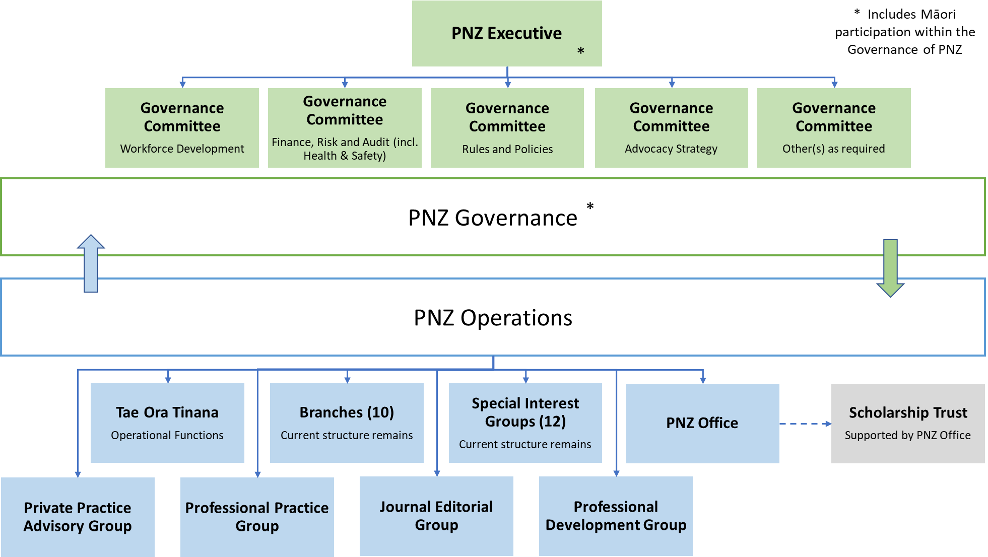

*NB: You will see some of the names for Committees and Groups have changed, a glossary of terms and definitions is on page 7 of this document.*

This work is in preparation for the member vote in August 2018 (information provided to members in July 2018), when a decision will be made on whether or not PNZ will transition to a unified organisation under a single constitution.

If you have any questions, or would like to discuss, please get in touch with Sandra Kirby or Peter Christie within the PNZ Office.

# Introduction

The decision was made in 2017 by members of Physiotherapy New Zealand (PNZ) that change was needed, in order for PNZ to deliver increased member benefits and value. This change journey is now in progress, with the Current State Analysis complete and documented. The future state Governance Model has been agreed by the National Executive and has informed the new Constitution.

This document is the next collection of material for review and feedback, the proposed Operating Model and Roles and Responsibilities.

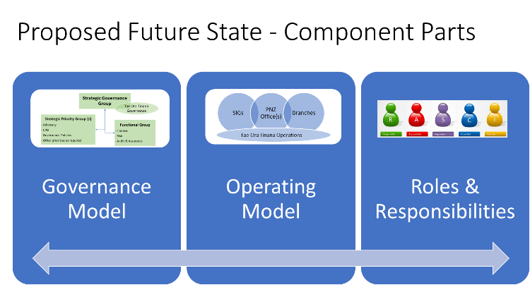

The **purpose of this document** is to present the Operating Model and clarify Roles and Responsibilities within that for the future state of PNZ. PNZ, for the purposes of this material, is referring to the proposed future state of a single unified organisation. A glossary of terms is listed below.

The **approach** taken began with building on the foundation of the design principles in co-design workshops, that provide the anchor for decisions. Next, decisions were made on the future state Governance Model, to support what will best enable the future direction of PNZ. The principles and governance model decisions have informed the PNZ Operations outlined in this document.

The overall **timeline** for developing the proposed future state is to provide information to members in July 2018 that prepares them for a member vote in August 2018. In preparation for this, a full package of material on each component part (Governance Model, Operating Model and Roles & Responsibilities) was presented at the Leadership Day on 25 May and the National Executive the following day, for their 26 May 2018 meeting. Feedback from these meetings has been incorporated into this final document to inform the Member Vote.

# Glossary of Terms

For the purposes of this document, below is an outline of the glossary of terms and the related description.

|  |  |
| --- | --- |
| **Name** | **Description** |
| PNZ | The unified entity, under one constitution, that encompasses PNZ Governance and PNZ Operations – as outlined below. |
| PNZ Executive – *currently known as National Executive* | The overarching governance group for PNZ, that sets the vision, strategy and direction for PNZ. This is a re-styled National Executive. |
| Committees | Committees provide a mechanism for the PNZ Executive to delegate responsibilities on key areas. |
| PNZ Governance | Incorporates all of the groups that make up the governance structure, including; the PNZ Executive and Committees. |
| Special Interest Groups (SIGs) | Groups of members that come together around specialist interest areas within the Physiotherapy profession. |
| Branches | Regional groups that provide opportunities for members to connect with other members in a geographical location and to access services to support their professional development. |
| Tae Ora Tinana | The Treaty partnership entity for Physiotherapy New Zealand. |
| PNZ Office - *currently known as National Office* | The Wellington-based office whereby the majority of PNZ employed staff are based.  NB: There is another office in Auckland run by NZMPA, this is considered separate for the purposes of this material. |
| PNZ Operations | All of the groups that make up the operational structure, including; SIGs, Branches, Tae Ora Tinana and the PNZ Office. |
| Co-Design Working Group | The group consulted with through the “current state analysis” work, with a member from each; Branch, SIG, Wellington Office and National Executive. |
| Governance Model | The framework that defines the governance of the organisation (PNZ), including structure, processes and accountabilities. |
| Operating Model | The framework of how PNZ delivers value to its members and customers as well as how PNZ will actually run itself. |
| Roles and Responsibilities | Clearly articulating the roles and responsibilities of and between groups. |
| Transition Period | The period of time between the membership vote (if successful) and the full implementation of the future state Operating Model and Governance Model. |

# Design Principles

What does Unity Mean? As defined by the Co-Design Working Group:

“*For PNZ to realise benefits and create the value for its Members described above, unity means Branches, SIGs and National Office working closely together to achieve common goals, as one organisation, delivering member services throughout our virtual network. It means introducing a universal business model, whereby Branches, SIGs and National Office have clearly defined roles, responsibilities, and accountabilities, based on overarching principles with respect to governance, finance and operations. It means collectively sharing the best of what we do, and making this standard practice.*”

## General Design Principles:

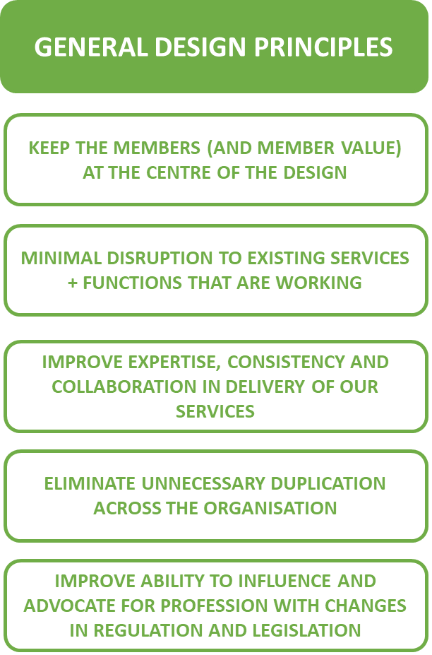There are a number of general design principles that were taken into consideration in the Governance Model and also apply to the Operations Model, alongside those that were developed by the Co-Design Group.

## Co-Design Group Design Principles

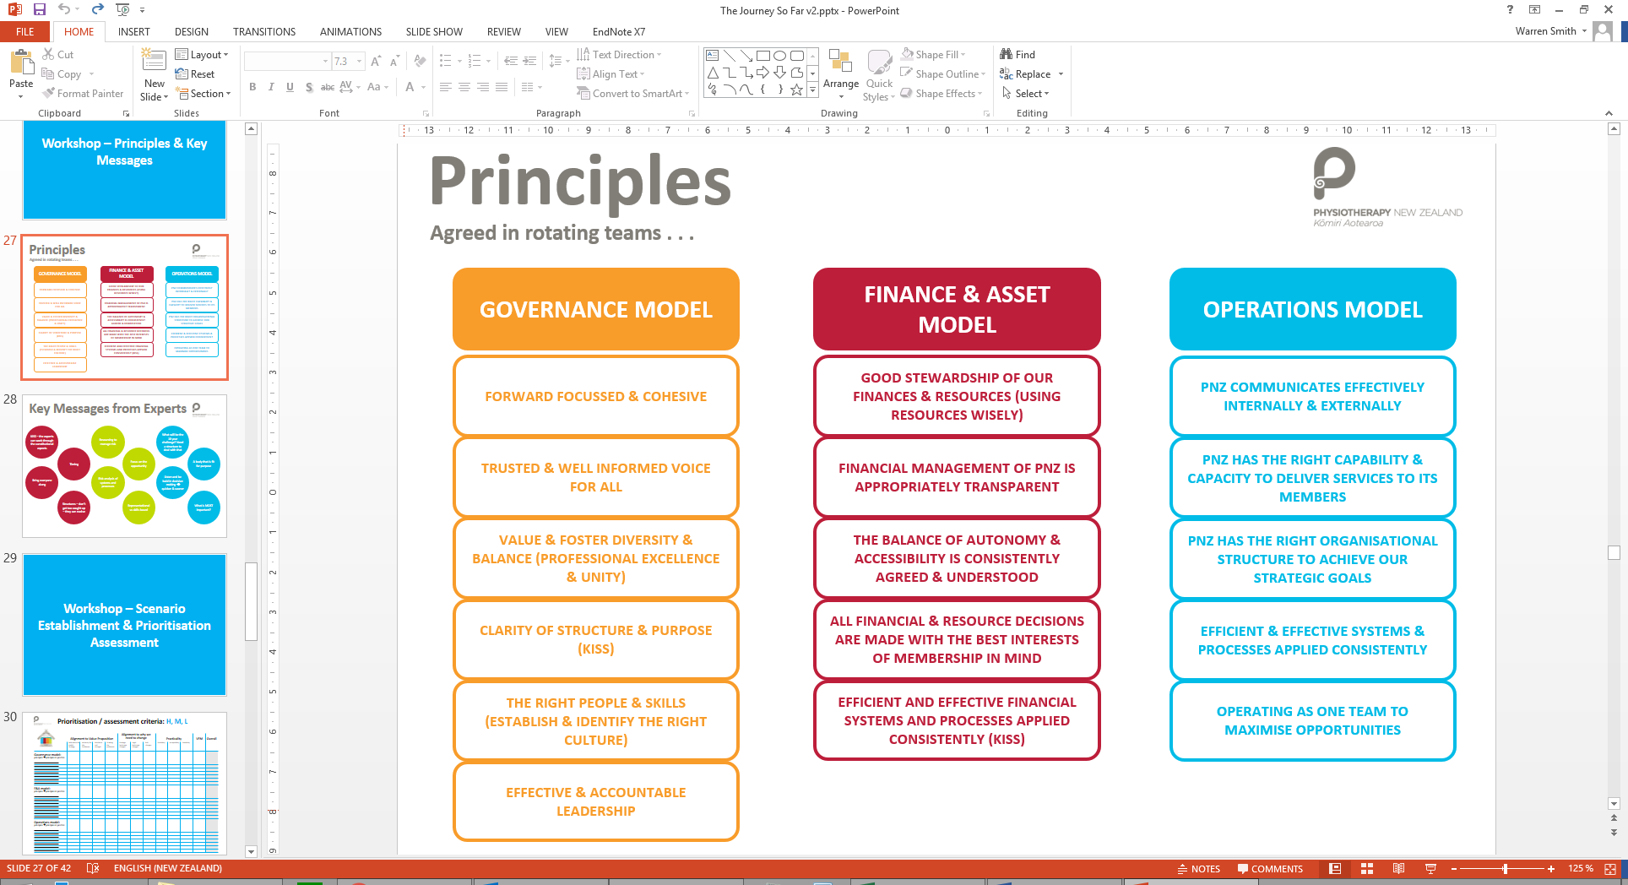The Co-Design group developed a set of design principles to be taken into consideration during the design of the future state. These principles have informed the direction of the operating model alongside the general design principles in 4.1 above, from which the agreed governance model has been developed. This document is focused on the Operating Model principles.

# PNZ Operations Overview

This section outlines the current state of PNZ Operations, highlights key assumptions and points of note from the Co-Design Working Group.

For a universal business model to operate effectively, PNZ needs to clearly define the roles and responsibilities of the PNZ Governance, Branches, SIGs, Tae Ora Tinana and the PNZ Office. The Co-Design Working Group agreed there were benefits to working as one, towards PNZ’s common goals, with each entity being clear about the contribution it makes to a strong and healthy organisation.

At the moment there are overlaps in what Branches, Tae Ora Tinana, SIGs and the PNZ Office do, and everyone does things slightly (sometimes very) differently. This is neither efficient nor effective, adds cost, and leaves our Members with different experiences depending on which part of the organisation they are interacting with, be that the PNZ Office, Tae Ora Tinana, their Branch or the SIG(s) to which they belong.

It is proposed that PNZ Operations consist of SIGs, Branches, the operations of Tae Ora Tinana, supported and enabled by the PNZ Office. The collective responsibilities of these groups provide for a distributed and virtual service delivery model.

Regardless of the roles that PNZ Operations play, PNZ’s Governance will continue to set the vision, goals and objectives of the organisation, as well as the strategic plan. Any annual business plans will be developed in the context of this strategy, with PNZ’s Governance having a national oversight, leadership and governance role. PNZ Operations will be collectively tasked with undertaking the operational activities to meet the strategy and report these back to the PNZ Governance level.

Below are the key focus areas that have been recommended by the Co-design group, which have informed the design of the new operating model:

1. Based on their previous work and following legal advice, the group agreed to a single legal structure whereby Branches and SIGs continue to exist (but not as separate legal entities), with clear roles and functions.
2. The core purpose of the collective organisation moving forward is to:
   1. Advocate for the profession
   2. Drive quality, through promoting best practice and professional development
   3. Facilitate active participation by members
   4. Deliver value for money member services.
3. The volunteer network which currently supports the work of Branches and SIGs will continue to operate. This is an integral part of PNZ and is to be preserved and encouraged.
4. PNZ’s status as a member of WCPT is unchanged. WCPT must be advised of any constitutional changes. The single entity will not impact a SIG’s eligibility to remain part of any sub-group of WCPT, provided it remains part of PNZ.
5. Trusts (such as the Scholarship Trust) will sit outside the legal structure but can be administered and supported by PNZ.
6. The new incorporated society will take over accountability for existing agreements and future service agreements, including any employment contracts or sponsorships, currently held by Branches and SIGs.
7. The subscription model of the new organisation is yet to be determined. Financial modelling with projected membership fees will be prepared before any vote is taken. There will be a clear focus on delivering value for money member services under the new structure.

Clearly, there are constitutional considerations when making changes to existing operating structures. Each Branch and SIG will be different in this respect, because of their specific constitutions, and any transition process will need to reflect these differences to avoid any constitutional issues. This has been thoroughly explored with PNZ’s lawyers to create the new Constitution.

Any changes to PNZ’s constitution will require a constitutional vote by the members – with information provided to members in July 2018 that prepares for a Member Vote in August 2018.

# PNZ Operations - Future State

### (“PNZ Operations” incorporates all of the Groups that make up the operational structure, including; SIGs, Branches, Tae Ora Tinana, the PNZ Office and the task focussed Groups.)

This section provides an overview of the areas considered to inform the future state Operating Model for PNZ. These considerations were informed by the consultation that has occurred across PNZ to date. These considerations flow into the high level design of the future state PNZ Operations outlined below (Section 7).

NB: This is not an exhaustive list of operational functions/services – they are the most relevant to provide an overview of a high level model. Additional detail is provided in the Roles and Responsibilities document.

## Annual Business Planning

PNZ Operations will formally connect the strategic direction with the operational delivery through the annual business planning and budgeting process.

Based on the agreed future state Governance Model, the strategic direction for PNZ will be set by the PNZ Executive, informed by members, and then provided to PNZ Operations to plan and implement. The formal process for aligning strategic direction with operational delivery is through the annual business planning and budgeting process.

Annual business planning and budgeting will continue, the reporting in the future state is proposed to go through the PNZ Office to FRAC to advise the PNZ Executive. This is to provide a coordinated PNZ Business Plan and Budget to the governance group which has overall accountability for the strategic direction of the organisation.

Reporting against these plans and budgets (including updated forecasts and variance reporting) will occur on a quarterly basis, with a more fulsome report at the end of the financial year. Guidance, and simple tools/templates will be provided to Branches, SIGs and Tae Ora Tinana through the PNZ Office, and will be standardised and proactively managed. This will include a central repository for tools and templates coordinated through the PNZ Office for consistency and cost efficiencies across offerings, as appropriate.

Under a single constitution, it is proposed that the annual financial cycles be aligned to a 1 July to 30 June cycle, to be aligned over the transition period. This will achieve alignment and consistency in reporting on financial and non-financial activity across the organisation.

An outline of the proposed annual business planning and budgeting process was provided to the PNZ Leadership Day and National Executive meetings in late-May 2018. Guidance and templates will be made available through the PNZ Office to support PNZ Governance and PNZ Operations (Branches, SIGs, Tae Ora Tinana and functional groups).

## Service Delivery

PNZ Operations will deliver member services through a geographically dispersed and diverse mix of people.

A single legal entity provides for standardisation across the organisation under one constitution. This does not mean centralising all services, as this would not align with the agreed design principles, and would be costly to undertake. This is why a virtual operation that delivers member services is recommended drawing on the collective skills of PNZ’s operational network.

PNZ is an organisation with a diverse and geographically dispersed workforce. There is a mix of;

* Permanent and fixed term staff,
* Volunteers,
* Branch and SIG committee members (volunteers and honorarium),
* PNZ Governance committee members (volunteers and honorarium),
* Contractors, and
* Tutors.

It is proposed that the diversity of this workforce remain and be empowered to focus on the areas of their strength, contributing the best of tools, processes and systems to the broader organisation.

*Examples where the organisation is operating like this now are; the PNZ bi-ennial conference is currently managed by the PNZ office with the programme developed by a volunteer committee, and ongoing Continued Professional Development (CPD) is organised by Branches and SIGs on a volunteer basis. It may be that the fee collection and registration for CPD is centralised in the future state, but delivering the member services remains unchanged.*

It is recommended that PNZ Operations and cross-functional groups will come together on a regular basis to leverage the skills, knowledge and expertise across the organisation – to support the operational delivery of priority functions and/or projects.

It is important to note that this new way of operating will take time to transition and embed. Staffing requirements in PNZ offices may need to change – but will have to be managed within agreed budgets.

## Centralised Corporate Services

PNZ Operations will have centralised corporate services support within the PNZ Office.

As noted in the agreed future state governance model, a single legal entity under one constitution provides for standardisation across the financial and business planning years as well as legal and contractual obligations (E.g. employment contracts). Centralising corporate functions support for PNZ Operations will provide a central point of coordination across policies, guidance, tools, systems and processes to be disseminated to the wider organisation.

As noted above, the capacity to support this transition will require the PNZ Office to leverage the virtual network of people across PNZ, where skills and experience align.

Corporate functions include:

* Finance,
* IT,
* Human Resources (including training and health & safety),
* Legal,
* Administration,
* Marketing and Communications (including websites), and
* Business Strategy and Planning.

NB: This list is just corporate functions, there is a more extensive list of services supported centrally by PNZ Offices outlined in the Roles and Responsibilities section (e.g. fundraising guidance).

The proposed new way of operating will create efficiencies for Branches and SIGs, for example; all employment contracts would transfer to the PNZ Office. This would provide a central repository of standardised documentation as well as oversight of employment terms.

### Communications

There was a rebranding strategy developed in 2012. This work was a big undertaking and included the statement that, “*the Physiotherapy NZ logo is our most valuable visual asset and will remain contemporary and distinctive for the life of the brand. It has two primary functions:*

1. *It clearly states that we are the representative body for practising New Zealand physiotherapists;*
2. *It presents the face of a unified health service which is able to be easily and effectively marketed to all stakeholders, whether professionals or patients*.”

Currently there is an inconsistent look, feel and brand between entities across websites, communications and letterheads, which can be confusing for members who hear different messages on a similar topic from groups they are a member of.

PNZ will continue to work towards better coordination and rationalisation across the range of websites, social media sites and other communications channels that are interacting with PNZ members and the public in the future state. This is so that groups will no longer be required to maintain multiple websites by themselves – standardised templates/tools and brand guidance would be provided by the PNZ Office to ensure a consistent look and feel for members and customers.

### Procurement

PNZ Office will centrally manage procurement on behalf of PNZ, this includes managing the contracts with preferred suppliers and subscriptions. The majority of procurement expenditure will occur through the PNZ Office and will provide for a discounted price when Branches or SIGs are looking to procure products or member services, allowing for approved discretion at a local level – e.g. local caterers.

NB: This will not preclude Groups from purchasing their own supplies locally and seeking reimbursement, as long as the purchasing aligns with the Group Budget/Business Plan and is within the authorised financial delegations of the purchaser. Reimbursement for small pre-approved expenses will occur within 10 working days of receipt of invoices as evidence of purchases. Further information will be provided within the finance policy and guidance developed by the PNZ Office.

## Financial Management

The PNZ Office will centrally coordinate the finance function, with oversight by FRAC and overall accountability by PNZ Executive.

The Co-Design Working Group discussed the impacts that a universal approach might have on the financial model for PNZ Operations, and what options this may open up for change. The discussions were underpinned by a desire to deliver universal membership benefits, improved value to Members and a simplified membership system, which could remove barriers to participation and lead to Member growth.

The baseline assumption in the design of the operating model is that the subscription model will not result in an increase in membership fees, and therefore, no direct increase in revenue to be taken from existing members. This means that the future state organisation (in the short term) will need to plan for operations within the current financial baseline.

NB: The future state subscription model has been developed in parallel with the Governance Model and Operating Model.

As outlined above, Annual Group Budgeting will continue to be compiled into an overall PNZ Budget, agreed by the PNZ Executive. Reporting against Budgets (including updated forecasts and variance reporting) will occur on a quarterly basis, with a more fulsome report at the end of the financial year (which through the transition, will all be aligned to end of year on 30 June). The guidance, tools/templates and support offered to Branches, SIGs and Tae Ora Tinana through the PNZ Office will increase. This will include a central repository for tools and templates being coordinated through the PNZ Office.

An outline of the detailed roles and responsibilities around the finance function, in the future state, is provided in the “PNZ Roles and Responsibilities Document”.

## Sponsorships

PNZ Office will centrally coordinate sponsorships alongside Branches and/or SIGs on behalf of PNZ.

PNZ Office will lead the development and coordination of a national sponsorship plan, in consultation with all groups within PNZ, to provide clarity on the future direction for sponsorships across PNZ.

In the future state, PNZ Office will transfer all current sponsorship agreements across PNZ, alongside the Group that currently owns the sponsorship arrangement. Where these sponsorship arrangements can be leveraged for the broader organisation, the opportunity will be presented to the Sponsor.

Any new sponsorship agreements will be managed by the PNZ Office, in line with the overall national sponsorship plan, with input from Groups.

## Member Involvement

PNZ Operations will continue to seek input and feedback from members, through delivering member services as well as through PNZ Governance.

PNZ recognises that the agreement for change is underpinned by a desire to deliver universal membership benefits, improved value to members and a simplified membership system, removing barriers to participation and lead to member growth. The importance of keeping needs and expectations of members at the centre of PNZ Operations and PNZ Governance is clearly recognised.

There is provision for members to be elected within PNZ Governance, whether it be on the PNZ Executive or on one of the Committees. There will also be opportunities for members to join the operational cross-functional groups (e.g. Private Practice Advisory Group, or Journal Editorial Group) to feed into the operations of PNZ.

The membership survey completed in 2017 has also informed the future state design. It will be important to maintain a direct connection with the voice of Members through the transition period and into the future state.

## Health and Safety

PNZ Operations will manage the H&S functions at an operational level, as outlined by FRAC and agreed at PNZ Executive.

Overall accountability for the oversight of H&S across PNZ sits with the PNZ Executive. While the governance group has the accountability, it is the responsibility of PNZ Operations to manage and report on risks and issues related to H&S. The requirement is to manage the day to day H&S requirements across PNZ through the monitoring and updating of registers (e.g. Hazards and Risks), as well as reporting on incidents in a timely way.

In order to provide transparency and clear line of site to those accountable, it is proposed that a centralised H&S Policy be developed and maintained by the PNZ Office, which provides standardised processes to be followed with templates and guidance for Branches, SIGs and Tae Ora Tinana to use. The oversight and strategic direction for this work will be provided by FRAC and the PNZ Executive.

It is recommended that H&S be a section within the quarterly and annual reporting framework to provide visibility to the governance group.

NB: As part of the Transition Period, PNZ will need to obtain information on who holds accountability at each site and what they are responsible for legally, as well as how the split between the liability of Directors with Officers works.

*Connection with PNZ Governance:*

FRAC will retain a delegated focus around H&S that provides advice and expertise to the PNZ Executive to enable intensive scrutiny of this important area. The CEO, and other management as appropriate, will at a minimum, attend all meetings. PNZ Operations are likely to input vital knowledge of day-to-day operational risks into proceedings and it is PNZ Operations that will be required to implement the strategic planning of the group.

## Standing Committees

All of the existing Standing Committees (with the exception of FRAC) will be functional Groups within PNZ Operations.

In the agreed future state Governance Model the Standing Committee structure is proposed to change. The majority of functions that are currently managed through Standing Committees will become part of PNZ Operations. An outline of the changes to Standing Committees is set out below:

|  |  |
| --- | --- |
| **Standing Committee Title** | **Proposed Future Role – Governance or Operations** |
| Finance, Risk and Audit Committee (FRAC) | Governance. |
| Journal Editorial Committee | Operations. |
| Private Practice Advisory Committee | Operations. |
| Professional Development Committee | Operations.  A PNZ Governance Committee will be created to develop and advise on a Workforce Development Strategy. |
| Professional Practice Committee | Operations. |
| Scholarship Trust | Sits outside of Incorporated Society. PNZ Office will continue to manage the trust funds and administers the grant process on behalf of the Scholarship Trust. |

It is proposed that a review be undertaken to provide clarification of purpose and roles and responsibilities – including how these groups receive support from the PNZ Office. However, it is proposed that the existing groups be utilised to support the operational delivery of these priority functions, to ensure continuity and experience remains. Retaining groups with representation from across PNZ Operations will be important, so that the full value of the extensive virtual network is supporting the operational delivery of the organisation.

## Treaty Partnership

The Treaty Partnership is an integral part of PNZ and will be woven into PNZ Operations.

The recommended Governance Model is that the functions of Tae Ora Tinana at the governance level and service delivery level are clearly defined and that appropriate integration be established that recognises the importance of the treaty partnership to PNZ in the future. As outlined in the PNZ Governance material, there will be Māori representation on the PNZ Executive, with nominations endorsed by Tae Ora Tinana.

Based on the current description of the role of Tae Ora Tinana from the PNZ Annual Report, the member services that would align with PNZ Operations is the development of Māori physiotherapists through various channels and networks. The current development focus is through collaboration with the schools of physiotherapy, allied health professions, Māori mentoring networks and the Ministry of Health.

It is proposed that clarity on how the PNZ Office can enable and support these member services will be worked through as part of clarifying roles and responsibilities as well as how Tae Ora Tinana will partner with PNZ Operations.

This work will be co-designed with Tae Ora Tinana to ensure appropriate recognition and clarity is provided through the process.

## Performance Measurement

PNZ Operations will have clear performance measures outlined at the group level within the annual business planning process.

Clear accountability and performance measures are important to ensure delivery of the PNZ Operations is on track and aligned with the strategic direction of the organisation, including the agility to respond to changing contexts. Evaluations against expectations play a part in succession planning and are a key opportunity to ensure PNZ Operations has the skills and capability it needs to function effectively now and for the future.

It is proposed that measurement of performance is standardised and documented in a robust and transparent way, aligned with the strategy and refreshed annually. This will provide for effective, transparent and accountable PNZ Operations.

In the future state, PNZ Governance will set and monitor progress against the measures at PNZ Operations level and at the Branch, SIG and Tae Ora Tinana level. NB: Individuals’ performance will be managed through the employment contract or other contractual arrangements, as per agreed performance reporting lines.

# Proposed Operations Structure

Based on the Principles identified, and the considerations outlined in the design of the future state Operating Model – a high level PNZ Operations model has been outlined below:

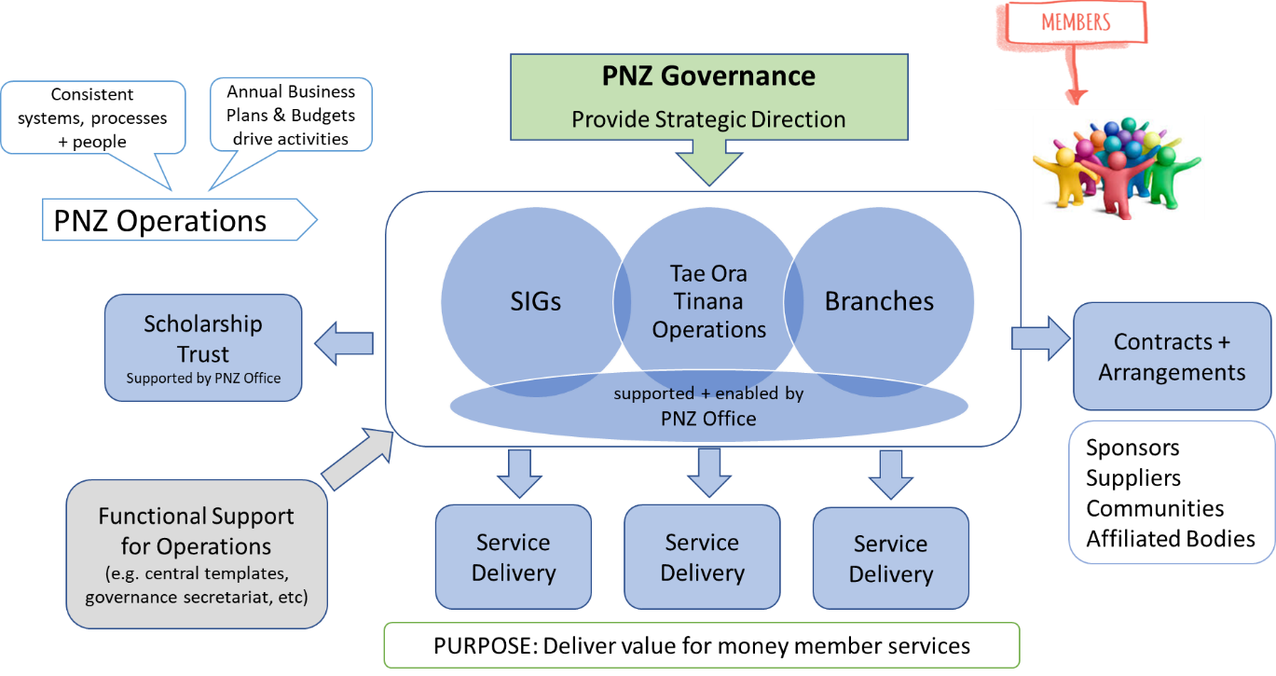

A structural view of the organisation is outlined below, including both PNZ Governance and PNZ Operations:



# Roles and Responsibilities

To provide the next level of detail under the Governance Model and Operating Model material, a Roles and Responsibilities document has been developed.

The Roles and Responsibilities document outlines the following areas – utilising the RASCI Model (with an adjustment for the PNZ context to include “G”):

|  |  |  |
| --- | --- | --- |
| **Heading** | **Descriptor** | **PNZ-wide or  Group specific** |
| **R**esponsible | The Group (or person) who do the work to complete the task. There is **at least one** group with the "R" of responsibility*,* others can be delegated to support in the work required. | PNZ-wide |
| **A**ccountable | The one ultimately answerable for the correct and thorough completion of the deliverable or task, and the one who delegates the work to those *responsible*. In other words, an *accountable* must sign off work that *responsible* provides. There must be **only one** *accountable* specified for each task or deliverable. | PNZ-wide |
| "**G**roup" Accountability | Accountability to deliver the "Group" component of the service or function. This may contribute to the PNZ-wide service or function. | Group specific |
| **S**upported | Resources which play a supporting role in implementation*.* Unlike *consulted,* who may provide input to the task, *support* helps complete the task. | PNZ-wide |
| **C**onsulted | Those whose opinions are sought, typically subject matter experts; and with whom there is two-way communication. | PNZ-wide |
| **I**nformed | Those who are kept up-to-date on progress, often only on completion of the task or deliverable; and with whom where is just one-way communication. One-way communication - whether it be from PNZ Office to Groups, or from Groups to PNZ Office | PNZ-wide |

This material will not remain static, as the organisation adjusts through the transition period and into the future state, there will be additions or edits agreed to the Roles and Responsibilities document.

NB: This is intended to be a guide to clarify understanding of the operations in the future state, not an exhaustive list of everything the organisation does.

# Next Steps

## Timelines

This section outlines the next steps for the future state work currently underway.

The material compiled to date was socialised at the PNZ Leadership Day on 25 May and the National Executive meeting on 26 May 2018. The feedback from these meetings has been incorporated into the final material that will be sent to members in July 2018 for the member vote in August 2018. The member vote will decide on whether PNZ will become a unified organisation under a single constitution.

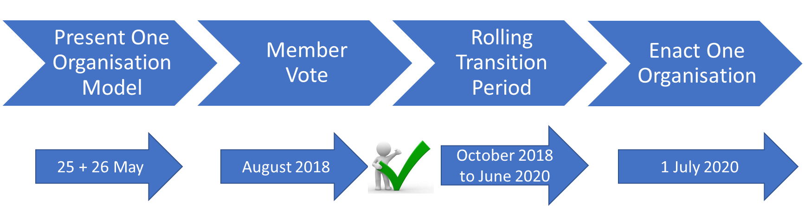There will be a rolling Transition Period, subject to a unifying vote from members to proceed. This period will begin from October 2018 through to June 2020. More information on the rolling transition period is outlined below in 9.2. The future state will formally take effect for the whole organisation on 1 July 2020.

## Rolling Transition Period

Subject to a unifying vote from members to proceed, it is proposed that a Rolling Transition Period begin from October 2018 through to 30 June 2020. The transition period extends over a period of 12 – 18 months, to allow for alignment of core processes; for example, financial reporting years. It is proposed that the financial years of groups will transition to the future state as their existing year ends occur from October 2018.

An outline of key considerations when planning for the rolling transition period are outlined below:

* How the existing capital and reserves of individual entities will be accounted for / ring-fenced within a new structure;
* Individual transitional arrangements will be agreed between the new Incorporated Society and each entity before disestablishment of the existing SIG/Branch legal structure. This will state any special legacy arrangements to ensure existing assets, relationships and affiliations are managed in a mutually agreed and timebound way.
* Employment agreements will be transferred to PNZ Office, subject to a consultation period with any affected staff.
* Sponsorship agreements within SIGs and Branches will be transferred to PNZ Office to manage alongside the SIG or Branch currently responsible for the relationship.
* There will be continuity within National Executive for a period to provide consistency in leadership through the transition phase.
* A review of the PNZ Strategic Plan will occur prior to 1 July 2020.